**Sequence Diagrams:**

**For class number 1, Customer:**

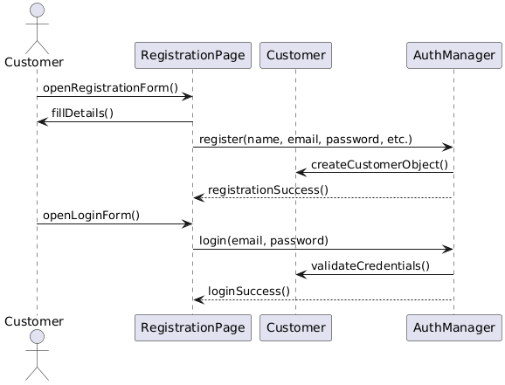

**For class number 2, Account:**

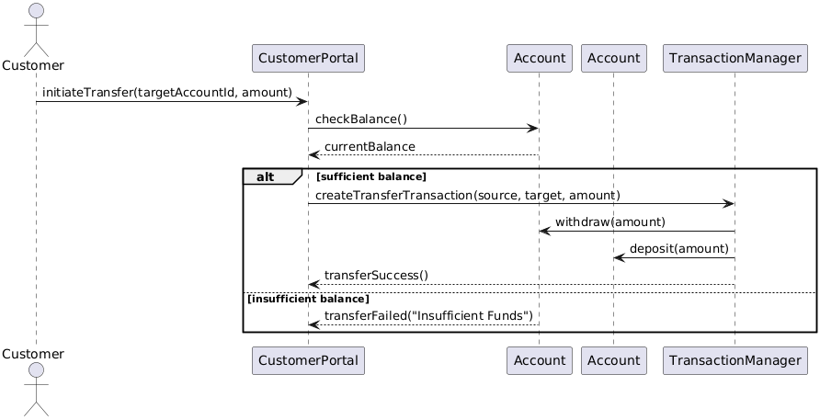

**For class number 3, Transaction:**

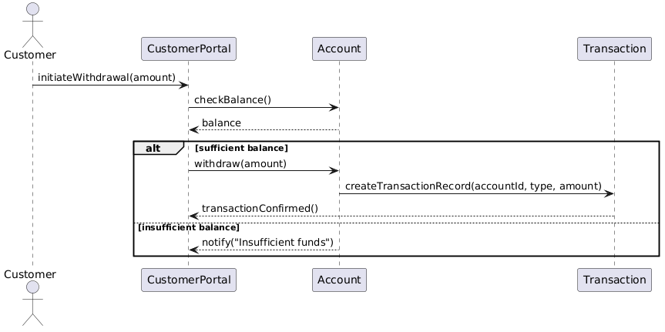

**For class number 4, Loan:**

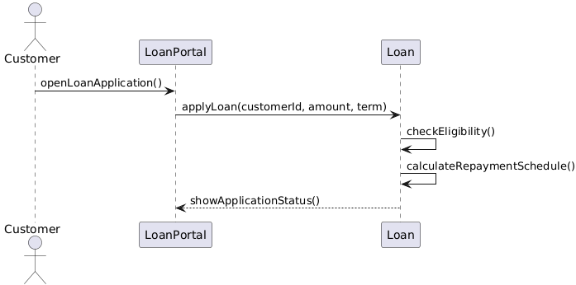

**For class number 4: transferFunds():**

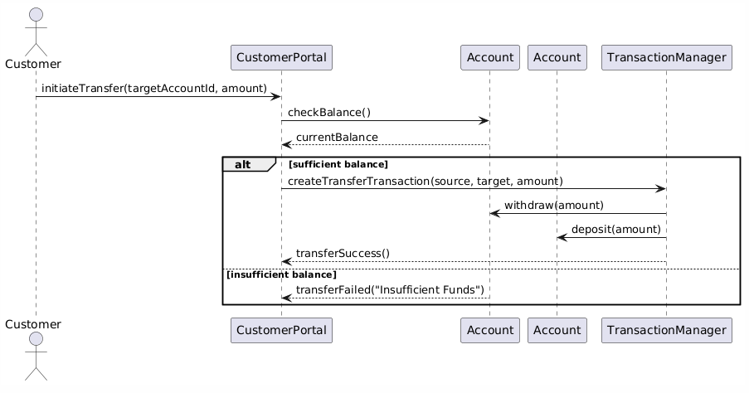

**For class number 5, Transaction:**

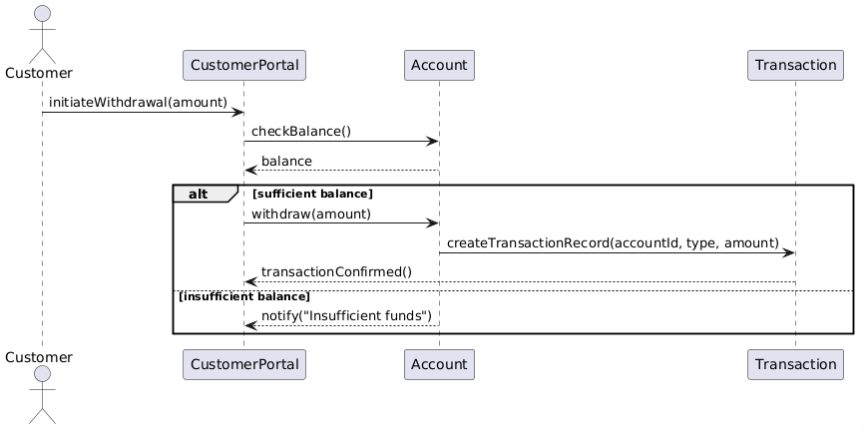

**For class number 6, Feedback:**

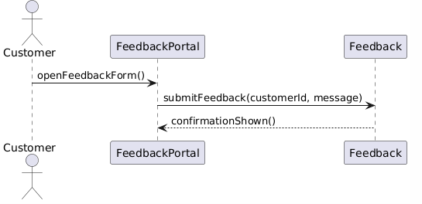

**For class number 7, Employee:**

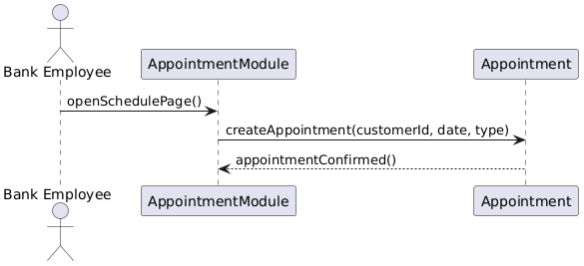

**For class number 8, Admin:**

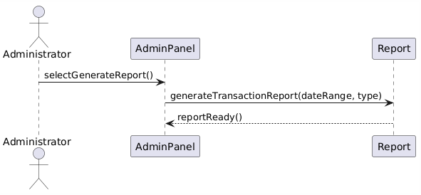

**The eight class diaram for number 9:**

